Thermal expansion of iron-rich alloys and implications for the Earth's core
Bin Chen¹, Lili Gao¹, Ken-ichi Funakoshi², and Jie Li¹
- Department of Geology, University of Illinois at Urbana-Champaign, 1301 West Green Street, Urbana, IL 61801, USA
- Japan Synchrotron Radiation Research Institute, Spring-8, Hyogo 679-5198, Japan

The Earth’s core makes up nearly one-third of the planet’s mass. Its composition, property, and dynamics are fundamental issues in the study of the Earth’s interior. Cosmochemical studies of meteorites and geochemical analysis of samples from shallower portions of the Earth suggest that the core is made of iron Fe-rich alloys containing Ni and one or more lighter elements such as S, Si, C, O and H. A critical test for any candidate core composition model is that it must be able to reproduce the physical properties of the core, such as density profile and velocity profiles of the Earth’s interior. One of the most widely used models is PREM. To perform the test of consistency between a composition model and the PREM model, we must know the thermal state of the core and the equation-of-state (EOS) of various Fe-rich alloys at the pressure and temperature conditions of the core. A survey of literature revealed a significant lack of thermal expansion data on Fe-rich alloys under static high pressure. In this study, we have determined thermal expansion of the iron–sulfur compound Fe₃S, Fe, and Fe–Si alloys using in-situ synchrotron techniques. The unit-cell parameters and thermal expansivity of Fe₃S have been determined by using synchrotron x-ray diffraction techniques and externally heated diamond–anvil cells at pressures up to 42.5 GPa and temperatures up to 900 K. Our data at 42.5 GPa and 900 K suggest that 2.1 at. % sulfur produces 1% density deficit in iron. We have also carried out energy-dispersive x-ray diffraction measurements on pure iron and Fe-Si alloy samples that were placed symmetrically in the same multi-anvil cell assemblies, using the SPring-8 synchrotron facility in Japan. Based on direct comparison of unit cell volumes under presumably identical pressures and temperatures, our data suggest that at most 3.2 at. % silicon is needed to produce 1% density deficit with respect to pure iron.

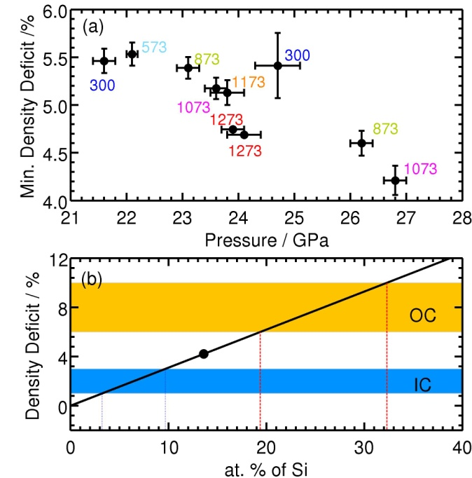
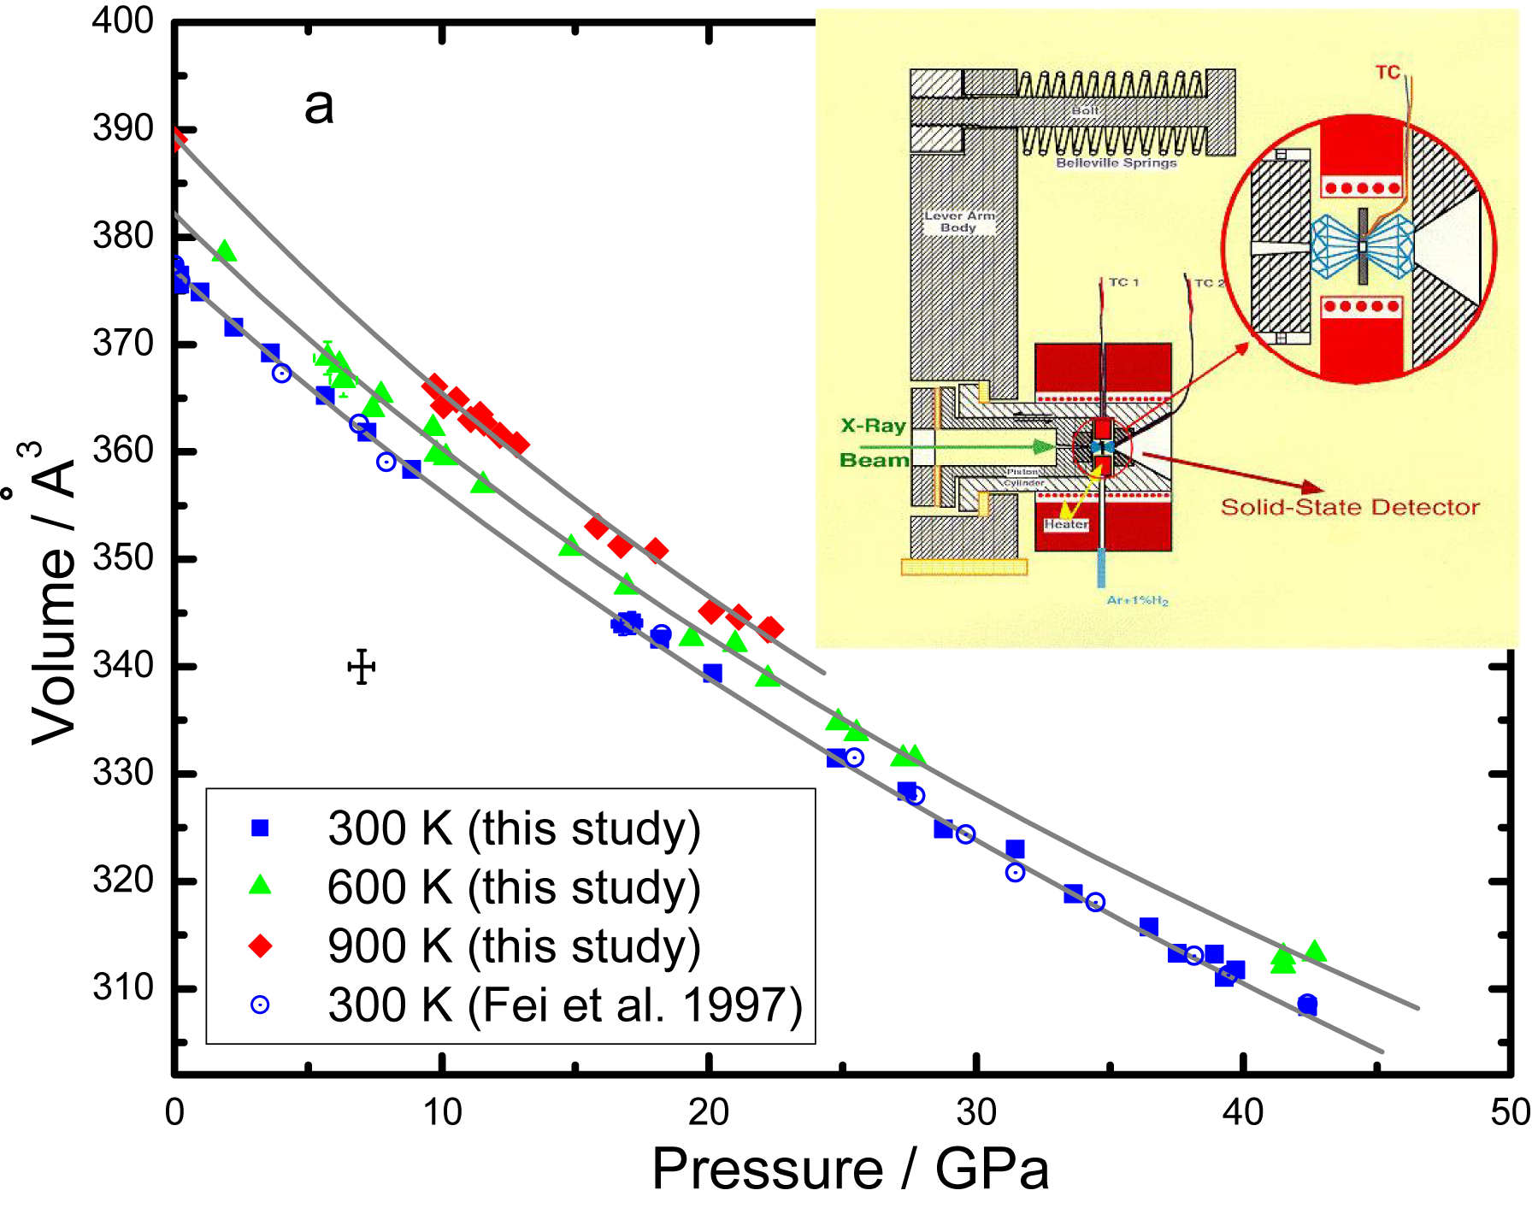
Fig 1. Left:Isothermal compression data of Fe₃S at 300, 600, and 900 K. The three lines are the third order Birch-Murnaghan EOS fits to the compression data. Top-inset is the experimental setups of an externally heated diamond–anvil cell using in-situ x-ray techniques. Right: (top) Minimum density deficit between hcp–Fe_{0.864}Si_{0.136} and hcp–Fe under different experimental conditions. Density deficit is defined as the absolute density difference divided by the density of pure iron. Numbers next to symbols denote temperatures in Kelvin. (bottom) Density deficit versus maximum Si content in Fe–Si alloy with hcp structure. Yellow and blue regions labeled ‘‘OC’’ and ‘‘IC’’ indicate density deficit of the outer and inner core compared with pure Fe, respectively . The filled circle represents the minimum density deficit produced by 13.6 at.% Si, based on data in a. The solid line represents a linear relationship between density deficit and Si content; dotted and dashed lines enclose the ranges of maximum Si content in the IC and OC, respectively.
PUBLICATION
B. Chen, L. Gao, K.-i. Funakoshi, J. Li. “Thermal expansion of iron-rich alloys and implications for the Earth's core”. Proceedings of the National Academy of Sciences 104: 9162-9167 (2007).
Acknowledgement of funding support: The U. S. component of this research was conducted at the diamond-anvil cell beamline X17C of the National Synchrotron Light Source of the Brookhaven National Laboratory and was supported by the U. S. Department of Energy (Grant #DE-FG03-01ER15218) and by the National Science Foundation via the Consortium for Materials Properties Research in Earth Sciences [COPMPRES] under EAR-01-35554 and 06-49658.

